YOUR LAST NAME: APPLICANT’s LAST NAME:
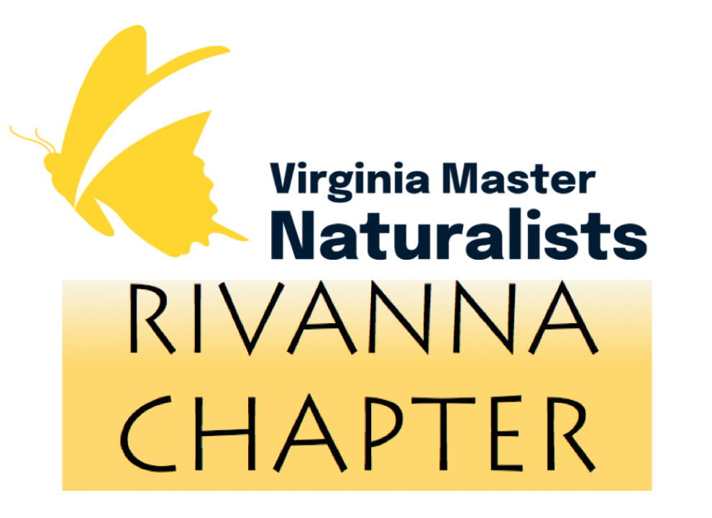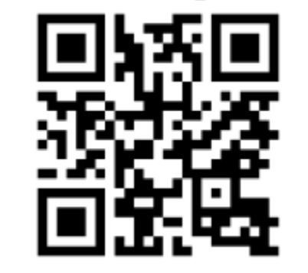
Recommendation Form for Rivanna Master Naturalists
A. Please complete and email this form as a Word document, .docx, PDF or JPG, or as a scan, screen snip, cell phone shot, or photograph. Type in the spaces to register an answer. You can also paste the questions into a new email. Handwritten replies are also fine—just use the question numbers to identify the question, numbers only—don’t try to cram your answers into the spaces below if handwriting. Take as much space as you need.
B. Please tell us about your impression and knowledge of the applicant’s enthusiasm or motivation for volunteering, or their involvement with volunteer work. Scroll down to see more information about the RMN program. Specific, descriptive responses will help the applicant more than general compliments. This is not a character reference—your response helps us understand whether the applicant has the time, energy and drive to be an effective volunteer.
C. In the email Subject Heading, or at the head of your recommendation, please title your e-form “LAST NAME of APPLICANT YOUR LAST NAME Reference”.
D. Please return to rivannamnapplications@gmail.com by JANUARY 5th. Late submissions might disqualify the candidate’s application. Contact this email if you have any trouble with the form and we’ll gladly help you out. Mailings must be received by JANUARY 5TH, mailed to RMN, P.O Box 8284, Charlottesville, VA 22906.
This information is fully confidential. It will never be shared with the applicant or anyone except a small review committee, and is deleted after the application process.
Your Name: Applicant’s Last Name:
Your ‘best’ phone number or email address:
(in case we have a question or a problem with your form—this will never be redistributed)

1. How long and in what capacity have you known the applicant?
>>

2. What aspects of the applicant’s background would make this applicant qualified and suitable for the volunteer service described? Please be as specific and descriptive as possible.
>>

3. How would you describe the applicant’s character, temperament and attitude as it relates to working with others, or in this case, volunteering for the Master Naturalist’s mission to support our natural environment as a citizen scientist, educator, or steward?
>>

4. The Virginia Master Naturalist state office sets rules and guidelines that must be followed for the safety and security of its participants. Please comment on the applicant’s willingness and ability to operate within a structured program or guidelines.
>>

5. Do you feel that there are any issues that would interfere with the applicant’s ability to care for children under his/her/their supervision – anything that would endanger the child’s well-being? If yes, it is extremely important that you provide some information, which need not be detailed.
>>

6. Do you have any reservations about this person’s involvement with the Rivanna Master Naturalists? If YES, please offer a basic explanation.
>>

YOUR PRINTED OR E-SIGNED SIGNATURE and DATE:

Thank you so much for taking the time to complete this reference form. You have made a vital contribution to our mission that helps us select people who are motivated and willing to serve in volunteer roles, and will ultimately provide a benefit to our natural resources and local environment.
ABOUT VIRGINIA MASTER NATURALISTS
The VMN program partners primarily with the Virginia Cooperative Extension based at Virginia Tech and several state agencies. The Rivanna Chapter, based in Albemarle County, trains volunteers to carry out natural resource education for all ages, citizen science, and stewardship service projects in their communities. In 2022, 151 Rivanna volunteers gave 12,000± hours in service to nature in our area, which amounts to a monetary equivalent of about $375,000. Statewide, 30 master naturalists chapters contributed about 211,000± hours valued at $6.5 million in effort. To see more information about the RMN’s mandate, review our “Introducing the RMN” PDF at
www.vmn-rivanna.org

PLEASE RETURN THIS COMPLETED FORM to Rivanna Master Naturalists no later than January 5th or the application may be ineligible.
rivannamnapplications@gmail.com

